Chapter – 6
Marathwada Hydrological Information System Using ArcHydro
6.1 Introduction
The study area is Marathawada region selected, the Hydrologic Information System can be developed using the selected data model Arc hydro. The ArcGIS Hydro data model Arc Hydro is a geospatial and temporal data model for surface water resources that operates within ArcGIS and supports hydrologic simulation models. Arc Hydro defines a set of water resources feature classes (classes with Point, multipoint, polyline, polygon, annotation or network features) in ArcGIS (such as watersheds, monitoring points) and the relations between these classes and stores them in a geodatabase. A geodatabase is a special form of a relational database that stores geospatial coordinate data of a GIS layer in one field in a relational data table [95]. The complete model consists of five categories to divide water resources elements: network, drainage, channel, hydrography and time series.
This model is used for this research because it can automatically transfer a geodatabase into a Hydrologic Information System and therefore has great potential to be used for water resources studies. The model uses an ArcGIS geometric network to trace the flow of water through a stream network and can relate drainage, stream confluences, water discharge and monitoring points required in this research using ArcGIS relationship classes.
A geometric network is a connectivity relationship between a collection of feature classes in a feature dataset and consist of two fundamental components: edges and junctions. An edge is a type of network element that has a length and through which commodities flow: in this case stream reaches. A junction occurs at the beginning, end and intersection of two or more edges or along an edge and allows the transfer of flow between them: in this case the confluence of stream reaches, water discharge points and monitoring points. Edges are always polylines and junctions are always points and in a network they are topologically connected to each other [96].
An ArcHydro toolset was developed by Maidment (2002) to help create and manage Arc Hydro data. These tools are used to derive several data sets that collectively describe the drainage patterns of a catchment and that are used to create the geometric network.
The natural partner of the hydrographic description of water bodies is the study of water movement through them. Hydrologic data is obtained from field monitoring stations, such as stream flow and rain gage recorders and climate stations that record through time the variations in water flow and related quantities.
6.2 Hydrological Information System

The occurrence of water shows great variability in space and time and requires that adequate measurement networks are established to define spatial variability and that they are maintained over a sufficient period of time to define temporal variability of a water variable. Management of water services for domestic, industrial, agricultural and power generation - and protection from the vagaries of floods and droughts, requires information on storages and fluxes of water.
A Hydrological Information System (HIS) consists of the physical infrastructure, software and human resources to collect, process, store and disseminate data on hydro meteorological, hydrological, geo-hydrological and related variables. The physical infrastructure includes the data observation networks, laboratories for analysis of samples, communication systems, and data storage and processing centers. The human resources are the trained staff who observe, key-in, process, disseminate the data and maintain the equipment computers, etc.
The primary role of a HIS is to provide reliable data sets for planning, design and management of water resource and for research activities. The system should function in such a manner that it provides the information to users in time and in proper form. Sometimes, the scope of HIS is extended to provide data to users on a real-time basis for short-term forecasting or operational purposes [97].
The data collected for different hydro meteorological variables is called the raw or observed data. The raw data have to be processed to ensure the reliability of the resulting information. Both raw and processed data sets have to be properly stored -- processed data for dissemination and raw data to permit inspection and revalidation in response to queries from users.
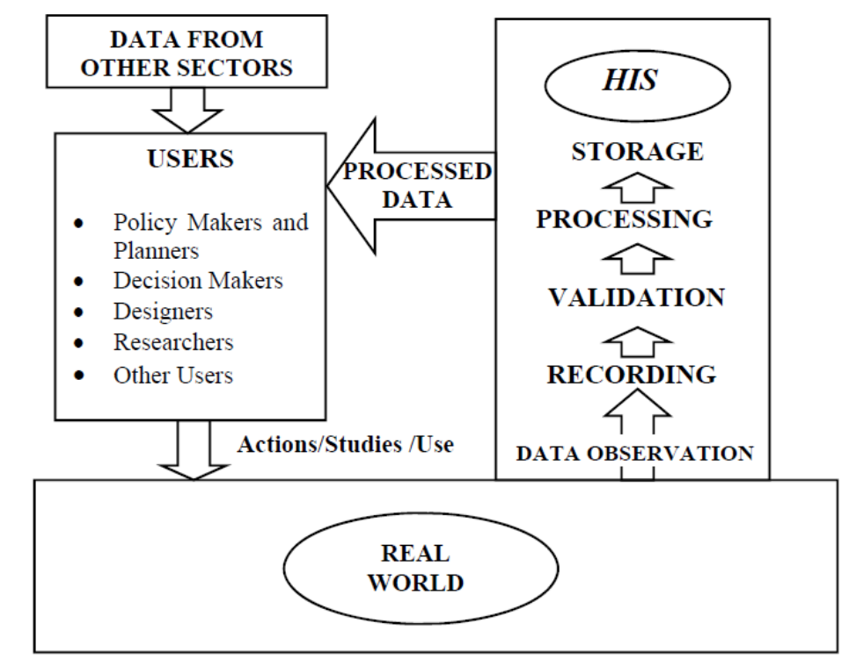
Fig 6.1. Schematic Diagram of A Hydrological Information System

The Principles of a Hydrological Information System are implied in the following paragraph :-
Hydrological:
Hydrology is the science of water in the Hydrological or water cycle and is concerned with its states, storages and fluxes in location, time and phase. Hygrometry is the sister science of hydrology which is concerned with the measurement of these states, storages and fluxes in the water cycle. It is a science because it is concerned with the scientific principles of repeatability and that measurements may be checked and validated.
Information:
Three key features of information are reliability, availability and presentation. Information is data which has been manipulated and processed to give them meaning and purpose. By definition, information serves a function and is created not simply because it is there to be measured or because of our curiosity alone. Unlike the mountaineer, we are not climbing Everest simply because it is there to be climbed- but because there is someone on the top who needs help. Function is important, not only in establishing the contents and structure of the information but also as a motivation for all involved in the development and maintenance of the HIS.
System:
The HIS is not simply a data collection or archive although it incorporates an archive. It is a logical and structured system to collect data which are subsequently entered into the computer, checked and stored and where also data may be compared, associated, related and combined to provide information in a form suitable to users. A system may also be seen as the integration of the user and the machine [98, 99].
6.3 The need for information:
The planning, design and management of water services for domestic, industrial, agricultural and power uses and protection from the vagaries of floods and droughts, requires information on storages and fluxes in water for safe and economic design and operation. The need is growing with a growing population.
The activities under HIS can be broadly classified in the following categories[100]:
- Assessing the needs of users
- Establishment of an observational network.
- Management of historical data.
- Data collection and transfer.
- Data processing analysis and reporting
- Data Exchange and reporting
- Data storage and dissemination

6.4 Building a geographic data model
A data model is simply a method for describing a system using a structured set of data. For example, the set of variables used in a computer program is the data model for the program. Data models provide an orderly way to classify things and their relationships. A geographic data model is a representation of the real world that can be used in a GIS to produce maps, perform interactive queries, and execute analyses. Geographic data models define a vocabulary for describing and reasoning about things located on the earth. By agreeing on a common vocabulary, practitioners can readily share data, tools, and analyses. Geographic data models also provide ways to model systems of behavior describing how things in the landscape interact with each other.
6.5 Database integration
The task of tracing the path of a raindrop as it flows through the landscape involves knowing the drainage system on the land surface, the natural flow system in streams, rivers, lakes, and constructed flow systems such as ditches, pipes, and canals. The effects of dams, bridges, and pumping systems on the flow patterns also have to be accounted. This requires an additional kind of functionality, namely knowledge of the connectivity among features in different data layers. ArcGIS supports a formal network connectivity model of points and lines in its network analysis system, and Arc Hydro adds relationships between network junctions and related hydrologic features, such as watersheds, water bodies, and monitoring points. This "feature-to-feature" connectivity is an example of an important aspect of ArcGIS. It supports "feature- oriented operations" as well as "layer-oriented operations." In other words, besides collecting all the watersheds in one data layer, and all the stream segments in another layer, relationships in ArcGIS can also be established between an individual watershed that drains to a particular stream segment, just as it does in nature. Moreover, these relationships are stored permanently as part of the data structure [101].
6.6 ArcGIS features
Three aspects of ArcGIS appear as critical factors in designing Arc Hydro: networks, the geodatabase, and object modeling [102].
6.6.1 Network features
The river network of streams, rivers, and water bodies is an easily recognized set of water features on a topographic map. ArcGIS has a special class of more sophisticated point and line features called network features, consisting of lines or edges joined by points or junctions. A network has three components: its geometric data specifies where each point or line is located in space, its topological data specifies how the edges and junctions are joined to one another, and its addressing data specifies a location along a river, somewhat like a street address.
Taken together, these properties of network features provide a more robust structure for network representation in GIS than was previously available. A GIS river network with centerlines through water bodies permits continuous graphical tracing of water movement through the flow system.
6.6.2 Geodatabases
Data can be stored in digital form in three ways: as flat files, as fiat files with a data dictionary, and as a relational database. A flat file is simply a listing or table of the data in text form, for example, a table for daily stream flow discharges over a year, with columns for each month and rows for each day of the month, and summary statistics of monthly flows at the bottom of each column. A fiat file with a data dictionary is a more structured data format in which each column or field has a special data type and a header title, each row or record contains a data value, and the result is stored as a binary data file that includes both the data and a dictionary specifying the field data types and titles.
Most recent data storage systems are now built on relational databases, such as Microsoft Access and Oracle. Even water resources data archives, such as the U.S. Geological Survey's National Water Information System, held for decades in specially constructed binary files, are being converted to relational database format. In the pre-AreGIS version of Arclnfo, the geospatial coordinate data describing the geographic features (Arc) was held separately from the attribute data describing those features (Info). In ArcGIS, all this data can be loaded into a relational database, so that the geospatial coordinate data of a GIS data layer is stored in just one field in a relational data table .This special form of a relational database is called a geodatabase.
In other words, we need the capacity to be able to link individual features within GIS data layers such as catchments, streams, lakes, and gages, so that we understand how these features interact with one another. The concept of permanent relationships within the geodatabase allows these connections to be made and retained. Since time series are also being stored in relational databases, the connection between geospatial and temporal data can also be created in the ArcGIS environment.
6.6.3 Object modeling
During the 1990s, object-oriented programming became a standard in the software engineering industry, typified by the Microsoft Office suite of products (Microsoft Word, Excel, Access, PowerPoint*). Objects from one application can be copied and used in another, for example a Microsoft Excel table can be inserted in a Word document. Tins is possible because t he Microsoft Office objects are built using a protocol called the Component Object Model (COM), which specifics how objects should interact with one another, thus enabling a Microsoft Excel table object to behave appropriately when inserted in an application environment different than the one in which it was created.
Visual Basic is the programming language used to build the interfaces to the Microsoft Office products, and a variant of Visual Basic, called Visual Basic for Applications, is used to construct macros and application programs that customize Microsoft Excel and Access to solve particular problems beyond their native capabilities.
The ArcGIS software also uses Visual Basic as its interface language, and its objects conform to the COM protocol. This means that ArcGIS objects can be copied into Microsoft Office applications and vice versa, so that an ArcGIS map can be inserted in a Word document or a Microsoft Excel graph. Moreover, data developed in ArcGIS and stored in a Microsoft Access personal geodatabase can easily be viewed in Microsoft Excel, and thus incorporated into hydrologic analysis. It is even possible to work directly with Arc Hydro data without using ArcGIS [103].
6.6.4 Arc Objccts
ArcObjects are a set of generic ArcGIS object classes used for building geodatabase models such as Arc Hydro. There are three kinds of Arc Objects:
- Objects: These are data tables that store only attributes, such as a time series data table.
- Features: Data tables that store both spatial coordinates and attributes (points, lines, and areas), such as a stream gage location.
- Network features: These are special points and lines called junctions and edges whose data tables store the connectivity between the junctions and edges, in addition to their attributes and spatial coordinates. Stream segments are represented by network features.
6.6.5 Network features are subdivided into two kinds:
- Simple network features: Formed by a single spatial feature and a single set of attributes.
- Complex network features: Formed by several connected spatial features and a single set of attributes.
The Feature class is subordinate to the Object class, so each feature inherits the attribute Object ID, a unique identifier of an object within its class. Besides Object ID and Shape, more attributes can be added to further describe the features. The Network Feature class inherits from the Feature class, so to the standard feature attributes is added the attribute Enabled, which defines whether flow can occur through a network feature.
In the Arc Hydro design process, a specialized geometric network was developed that adds additional attributes to the ArcGIS edge and junction features to support water resources operations. This is called the hydro network, During the design process, there was a considerable debate as to whether simple or complex network features should be used to build the hydro network. The decision was made to use simple rather than complex junctions because Hydrojunctions don't have complex switching patterns like electrical switch boxes do. However, complex edges were used so that Hydrojunctions could be placed on the interior of Hydro- Edges without breaking the edges.
6.7 Arc Hydro framework
The Arc Hydro framework provides a simple, compact data structure for storing the most important geospatial data describing a water resources system. This framework can support basic water resources studies and models, and can serve as a point of departure for the more extensive data models, that include time series and other Arc Hydro components. The framework contains information organized in several levels, as mentioned below [104]:
- Geodatabase: If a personal geodatabase is being used, this is a Microsoft Access .mdb file, or if an enterprise database like Oracle or SQL Server™ is being used, this is a relational database file on a server.
- Feature data set: This is a folder that stores feature classes within the geodatabase. The feature data set has a defined map projection, coordinate system, and spatial extent.
- Geometric network: This is where information that topologically connects hydro edges and hydro junctions is stored.
- Feature class: This is where information on individual geographic featun's is ston'd, such as watershed or stream segment information.
- Relationship: This is where features from one class are related to those in another. In this case, each watershed, water body, and monitoring point is located to a hydro junction on the network.
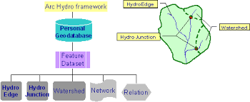
Figure 6.2. Analysis diagram for the Arc Hydro framework
Since Hydro junctions are topologically linked to Hydro Edges in the hydro network, the combination of this network and the other relationships shown in the analysis diagram means that the classes in the Arc Hydro framework are connected into an integrated data structure. This supports tracing water movement from one feature to another through the landscape. The creation of an integrated database, instead of a collection of data layers, is a key accomplishment of the Arc Hydro design in ArcGIS, providing a stronger foundation for building water resources applications in GIS than has previously existed.
So, how do you apply the Arc Hydro framework data model? All you need to begin is a set of streams, watersheds, water bodies, and points such as stream gage locations. In ArcCatalog, you create a new, empty geodatabase containing a feature data set called Arc Hydro, copy your data layers into it, then use ArcCatalog's geometric network wizard to build a hydro network. You need to do this in Arclnfo since geometric networks cannot be built using Arc View. Then, you add the standard Arc Hydro attributes to the data using the Schema Creation Wizard in ArcCatalog, and fill in the values of these attributes using the Arc Hydro tools.
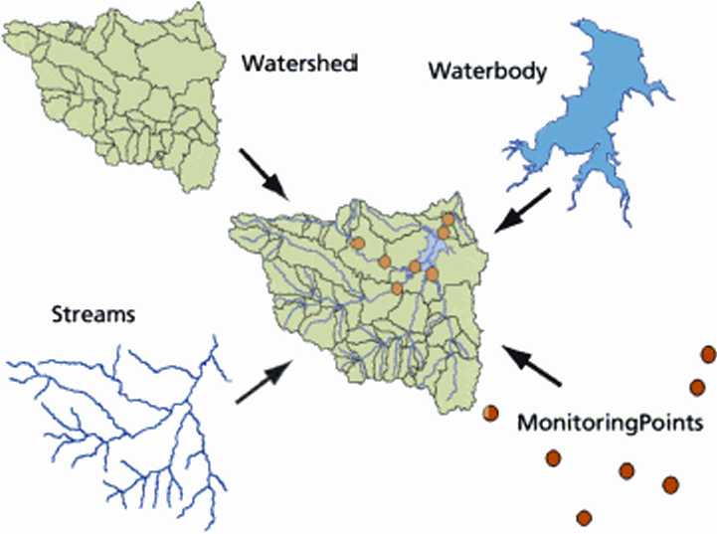
Figure 6.3 The Arc Hydro framework
In the above figure the Arc Hydro framework put together a basic data set for streams, watersheds, water bodies, and locations representing stream gages and water quality monitoring points.
6.7.1 Arc Hydro data model components
The complete Arc Hydro data model divides water resources data into five components:
Network: Connected sets of points and lines showing pathways of water flow
Drainage: Drainage areas and stream lines defined from surface topography
Channel: A 3-D line representation of the shape of river and stream channels
Hydrography: The base data from topographic maps and tabular data inventories
Time series: Tabular attribute data describing time-varying water properties for any hydro feature.
6.8 Marathwada Hydrologic information systems
Traditionally, the term "water resources data” has meant the time series of water measurements recorded at gages and monitoring sites. As GIS has become more popular in water resources, geospatial information for water resources has become available, including GIS data layers for stream networks, watersheds, water bodies, and measurement station locations. Arc Hydro combines geospatial and temporal data in a relational database format.
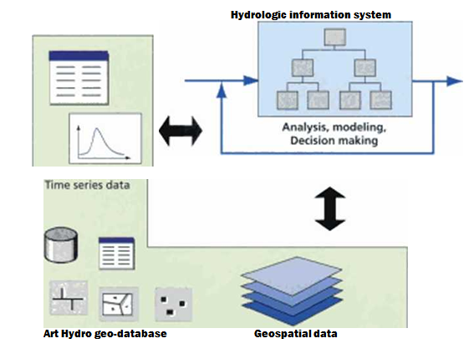
Figure 6.4. Relational database format of HIS
6.8.1 Precipitation and Evapotranspiration
The input of water to Earth’s surface as precipitation, and the output of water from the surface as evapotranspiration. Precipitation is any form of solid or liquid water that falls from the atmosphere to the earth’s surface. Rain, drizzle, hail and snow are examples of precipitation. In India, rain is the most common form of precipitation. With the main types of precipitation identified, the methods of measuring them are described and the potential errors identified. Experiments could be done with containers of different height or diameter to check the volume of water caught after a rainstorm.

Differences in the rates of evaporation in winter (low energy but high wind speeds) and summer (high energy and low wind speeds) can be illustrated by noting how long it takes to dry an impervious surface such as a road or pavement. If a surface is dry, the amount of evaporation is likely to be small, however sunny and windy the weather is. Hence we have to distinguish between the atmospheric conditions favouring evaporation, which we all the potential rate, and the actual rate of evaporation, which is determined by atmospheric conditions and the state of the ground. Actual evaporation or evapotranspiration, if the effects of transpiration through the plant leaves are also included, can be much less. In an extreme case, potential evapotranspiration in a desert is very high but actual evapotranspiration may be almost zero. Unfortunately it is difficult to measure. Methods of measuring evapotranspiration are described, together with a variety of estimation methods.
For those with access to the Internet there are a number of sources of precipitation data. The National Climate Data Center, amongst others, provides both long-term averages and actual monthly totals for some other parts of the world.

6.8.2 Types of precipitation:
- Rain is the most frequent form of precipitation on a global scale.
- Rain consists of innumerable drops of water with diameters up to about 6 mm.
- Rainfall from layer clouds tends to be less intense and with smaller drops than rain from convectional clouds associated with unstable air.
- Larger drops have greater kinetic energy and so have a greater impact on soil. They may cause erosion of the soil surface if the rain is sustained for any length of time.
6.8.3 Evapotranspiration
- Evaporation is the process of converting liquid water to a vapour state.
- Transpiration is the process of water loss through plant leaves and adds to the overall transfer of water from the ground to the atmosphere.
- Potential evapotranspiration is a climatically defined concept which indicates how much evapotranspiration would take place if the ground surface was continuously moist.
- For evapotranspiration to take place, we need an energy supply, usually heat from the sun, air movement to remove the evaporated moisture, and a humidity gradient so that the air above the surface is not saturated.
- Actual evapotranspiration depends not only on atmospheric factors but on the amount of moisture and the nature of the vegetation at the surface. A barren and totally dry ground surface, as in some deserts, will generate no actual evapotranspiration, though its potential rate would be high.

6.8.9 Measuring evapotranspiration
- Evapotranspiration can be measured directly by pans, lysimeters or eddy correlation systems.
- Evapotranspiration can be estimated indirectly by meteorological formulas or moisture budget estimates.
- The method to be used will depend upon resources or data availability and the climate system.
6.9 Research Objective
The main objective of this study is to develop and evaluate a Marathwada Hydrologic Information System that visualizes spatially water Resource making use of hydrologic parameter extraction and as a support tool for water Position monitoring.
To reach the main objective of the study, the following research questions need to be answered:
- What thematic layers, hydrologic parameters and water Level variables are required to determine spatial water Position of a basin?
- Which methods exist to automatically extract the thematic layers and parameters from raster elevation data and can these methods be incorporated in a HIS?

6.9.1 Conceptual model
A Marathwada Hydrologic Information System is a Geographic Information System capable of hydrologic analysis & this research consists of three Features:
- The development of a MHIS for a selected study area as Marathawada region, which cover eight districts.
- Visualization of Godavari basin layer covered by Marathwada Region.
- Precipitation (Rain Fall), Evapotraspiration & water yield Position of selective rivers in Marathwada Region.

6.9.2 MHIS Creation
Once all data is available the MHIS is to be build. First the drainage network is extracted from the selected Map and all tributaries, sources and sinks are connected, using the selected ArcGIS software and tools. Then created the river network will be compared with the field survey.
Then the quantity and quality measurements are connected to the network as attributes of the network at the junction and measure and sample points, and the database is exported to Excel.
6.10 Web-based Application Development of MHIS
The era of mobile technology opens the windows to the android app. The websites are vanishing and the mobile phones are emerging. It’s the time to change from conventional websites to apps, which has become part of our daily routine. We are introducing the android application software. It works not only as a website, but also it can work as a small Hydrological Information system for Marathwada region. Our multipurpose program is considering the user such Irrigation Department, PWD and other Water supply Department in Maharashtra. Project gives total solution to everyone. The application becomes also a mobile version for this proposed project. It gives us more comfort and a better user interface. It acts as an overview about the River Network & Dam Position.
Following screen shot shows the web-based application & graphical representation of River/stream, reservoir & Dam in Marathwada region with 8 districts. By using this GIS based platform we displayed the water yield position & evaporation of last four years (2013 to 2016) of various water bodies in Marathwada region. This statistical & graphical representation is useful for the planning, execution and monitoring of status of water resources. It is also helpful for Irrigation Department, PWD and other Water supply Department in Maharashtra.
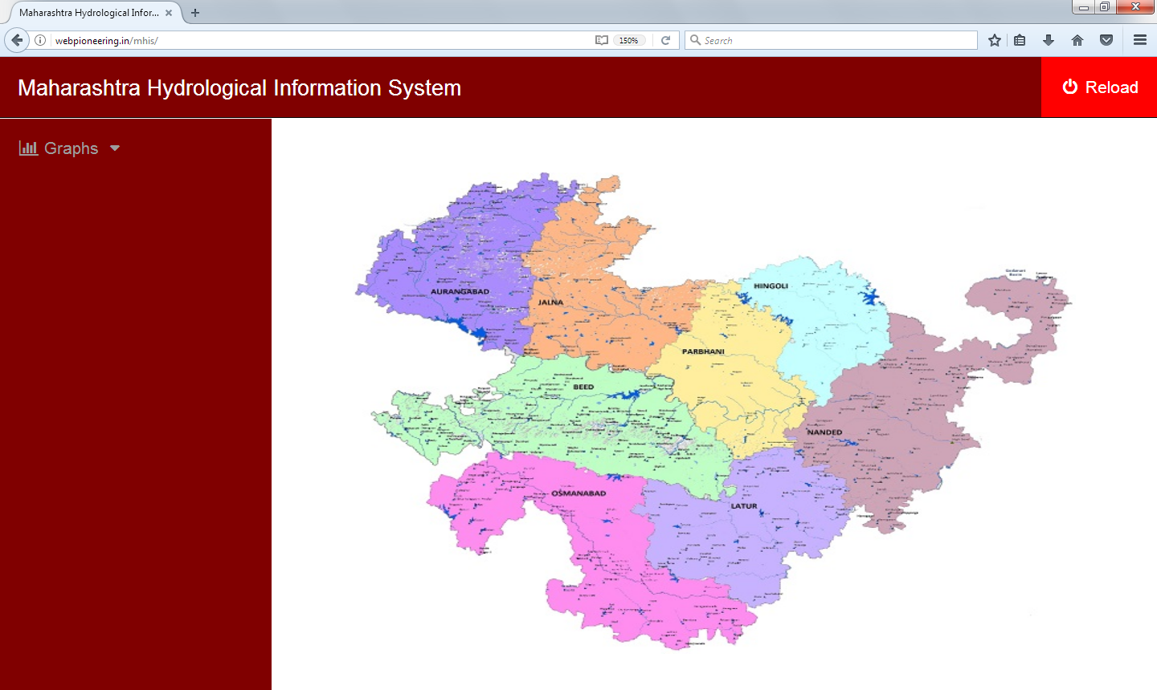
Figure 6.5 Marathwada Hydrological Information systems

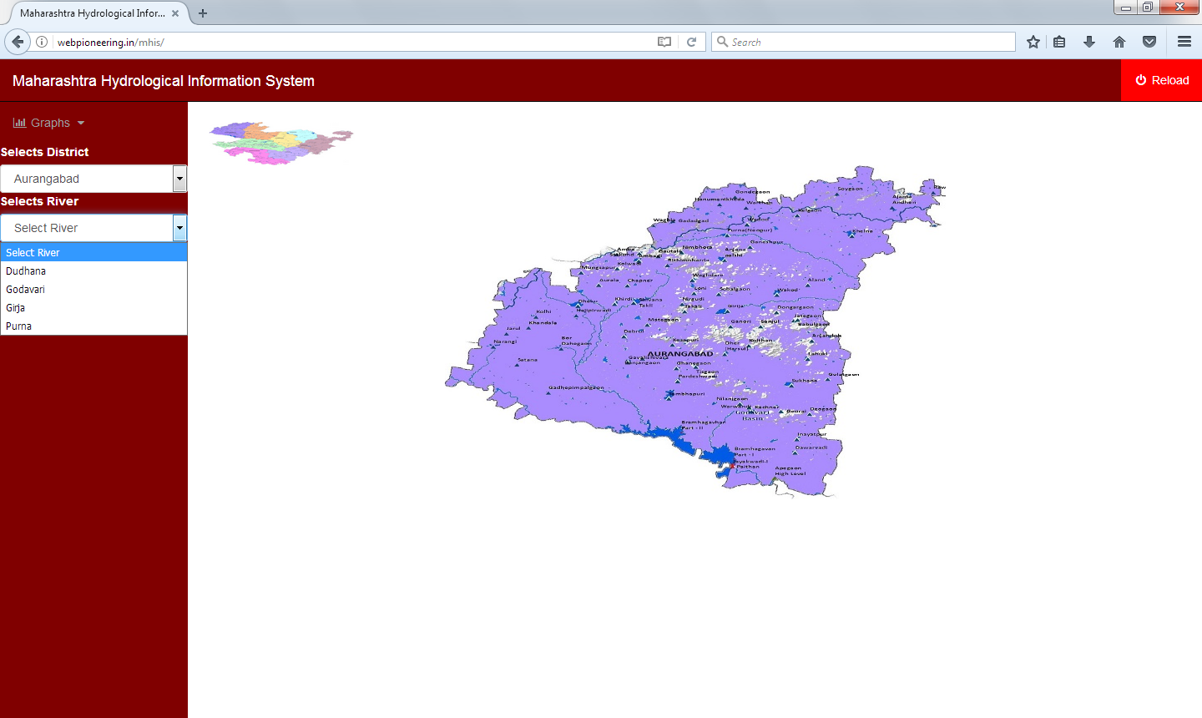
Fig 6.6: Aurangabad District River information

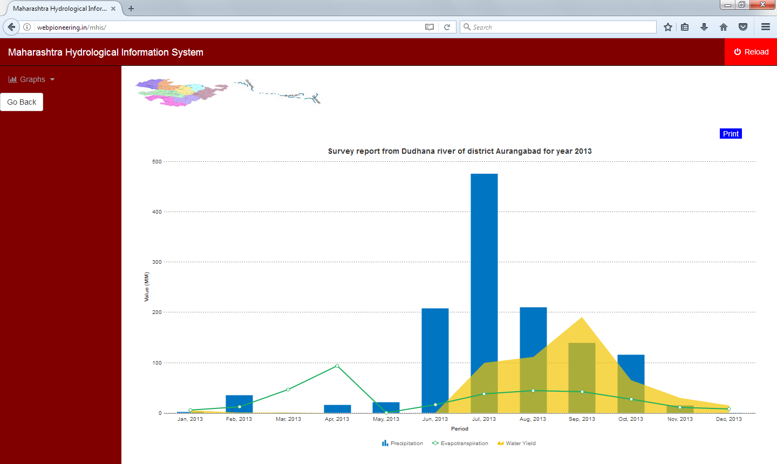

Fig6.6 Rainfall, Evaporation & Water Level interpretation of Dudhna River

Conclusion:
The development of a Marathwada Geospatial Web Portal is proposed as the best solution to Hydrological Information and Data Management. The Web Portal built around a hydrological data model synthesizes data from diverse sources describing the water resource, provides visualization tools and link to externally modeled results. This Geospatial Web Portal would provide a strong platform for the planning, execution and monitoring of status of water resources.

